Connection error in Postman:

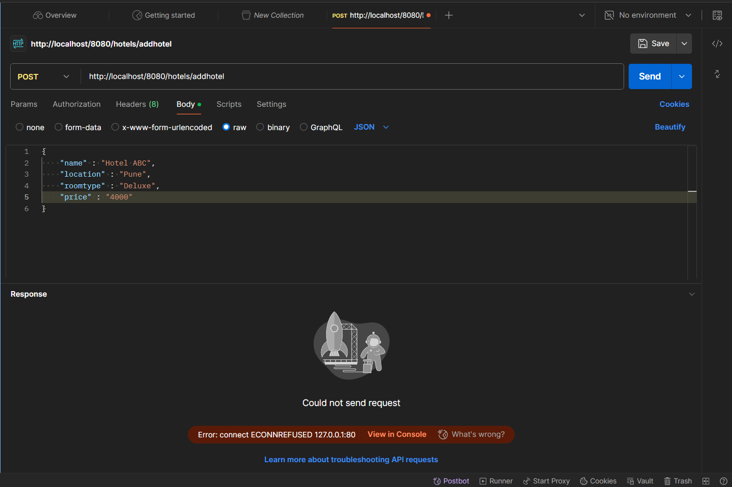Database Connection:

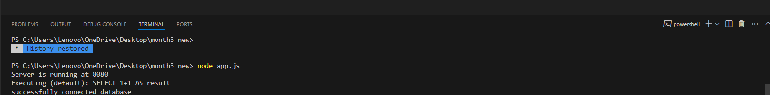Database: MYSQL

